Inter-coder reliability in the TV News Archive
A Report on Coding Issues, Countries and Actors in Belgian television news
Julie De Smedt, Ruud Wouters and Knut De Swert

Abstract
The News Archive is a continuous television news monitoring service that exists since 2003 and is hosted by the Media Policy Research Centre (steunpunt Media), a consortium including research groups from the four Flemish (Belgian) universities in which news and mass media analyses are done. All flagship newscasts of both the most important commercial (vtm) and public (Eén) broadcaster of Flanders (Belgium) are daily archived and coded. More specifically, information about the countries, issues and actors involved in news items are coded and stored together with the actual video footage of the news item. The main aim of the News Archive is to monitor the news and to report to and inform the media policy, and to feed the public and policy debate about the news content. Besides this, it also presents the scholarly community with an easy accessible database that allows for the quick retrieval of news items dealing with certain issues, actors or countries. As such more specific secondary coding can be executed. Notes on the end of this report present a non-exhaustive reference list of reports, papers and book chapters based on the data of the News Archive.
This report briefly introduces the archive and focuses on the training procedures of coders and inter coder reliability test results. Inter coder results show that inter coder values (Krippendorf α) of actors and countries are highly satisfactory. For issues, only major issue categories produce reliable results. These findings are discussed in light of maintaining a continuous census television news dataset.

Contact
For more information about the Media Policy Research Centre (steunpunt Media) or about the News Archive, please contact Julie De Smedt (Julie.desmedt@uantwerpen.be).
www.steunpuntmedia.be
www.nieuwsarchief.be

Introduction
The News Archive is a continuous television news monitoring service that exists since 2003 and is hosted by the Media Policy Research Centre (steunpunt Media), a consortium including research groups from the four Flemish (Belgian) universities in which research on news and mass media is done. This policy research centre is funded by the Flemish Minister of Media for the period 2012-2015. During the period 2003-2005 the archive was financed by the fund Max Wildiers (FWO) and since the end of 2005 it is financed by a project grant of the Flemish Government (Minister of Media).

Since 2003, all flagship newscasts (population data) of both the most important commercial (vtm) and public (Eén) broadcaster of Flanders (Belgium) are daily archived and coded. More specifically, the database stores the raw video material and coded information about the countries, issues and actors that are involved in the newscasts. The main aim of the News Archive is to monitor the news and to report to and inform the media policy, and to feed the public and policy debate about the news content. Besides this, it also presents the scholarly community with an easily accessible database that allows for the quick retrieval of news items dealing with certain issues, actors or countries. As such more specific secondary coding can be executed.

Training coders
On average twelve active job students (coders) watch the newscasts in detail and fill in a standardized coding form. The coders are bachelor or master students of the Faculty of Political and Social Science of the University of Antwerp. For every coded newscast, the students receive a financial compensation.
The project coordinator of the Media Policy Research Centre, also member of the research group Media, Movements and Politics (M²P), is responsible for the training of the coders and gives them feedback on a regular basis. First, each coder gets an individual training. During this training the code scheme is explained and the issue categories are shed light upon. After that, the student codes a first newscast as an exercise. In a next step, the trainer reviews this coded newscasts and provides the candidate coder with detailed feedback on the coding of the full newscasts. . When a coder meets the standards, he/she can start coding newscasts for the News Archive. As a standard procedure from the start of the project in 2003, every newscast coded undergoes a quick routine check, during which the trainer verifies the quality of the coded material for the most important variables, such as issue codes, actors, date and medium. Since 2011, regularly inter coder reliability tests are performed. This report is the first formal report on reliability of the coding of The News Archive.
Testing coders
For any researcher willing to report meaningful results when using a dataset based on content analysis, inter coder reliability is key. Content analysis data most of the time is generated by trained human coders. They watch, hear or read some sort of content, interpret the content, and have to categorize the content following a particular code scheme. As Hayes and Krippendorff (2007) argue “Conclusions from such data can be trusted only after demonstrating their reliability.” In short, inter coder reliability tests deal with the question of how sure one can be that the trends observed in a dataset are based on real differences in an observable empirical world or due to mistakes, inattentiveness or outright incompetence of coders.

In the next several paragraphs, we present inter coder reliability results for the most important variables used in the News Archive. We test inter coder reliability for countries, actors and issues. How did we proceed? In a nutshell, nine coders coded one week of news. These seven complete newscasts including from Monday until Sunday (seven complete newscasts). Not all of them coded all seven, but every newscast got coded at least four times. Table 1 presents the distribution of coders over newscasts. In total, 755 news items were analyzed by nine trained student coders.

Table 1: Distribution of coders over newscasts
 | 5/09/2011 | 25/09/2012 | 19/09/2012 | 8/11/2012 | 9/11/2012 | 30/06/2012 | 31/07/2011
 | Monday | Tuesday | Wednesday | Thursday | Friday | Saturday | Sunday
Coder 1 |  | X | X | X | X |  | X
Coder 2 | X | X | X | X | X | X | X
Coder 3 | X |  | X | X | X | X | X
Coder 4 | X |  |  |  |  |  | X
Coder 5 | X |  |  |  |  | X | X
Coder 6 | X | X | X | X | X | X | X
Coder 7 |  | X | X | X | X | X
Coder 8 |  |  |  |  |  | X
Coder 9 |  |  |  | X | X | X

In order to calculate inter coder reliability scores we relied on the KALPHA macro for SPSS provided by Hayes, which calculates Krippendorff Alpha values (Hayes & Krippendorff, 2007). Besides relying on this macro, we also made use of the web service ‘ReCal: Reliability Calculating for the masses’. This latter one is a reliability calculator that provides also other reliability measures like for instance percentage agreement or Cohen’s Kappa. The major downside of ReCal is that no missing values are allowed in the data submission system. We will make use of these programs to compare coding between coders.

In general, Krippendorff α values will be reported, sometimes accompanied by the percentage agreement between coders. Krippendorff α is a superior measure for reliability, since it takes into account the probability for a coder to code correctly by chance, and takes into account the measurement level of the checked variable. Generally, when the α-value for a certain variable is above ,800 the inter coder reliability can be considered sufficiently high. However, a researcher might want to raise this standard for variables that are extremely simple or straightforward. For example, when coding the sex of a person based on a picture, one might rightly expect reliability score to be much higher than .80. As a lower bound value, it is common to use α = ,667. Alpha values below this lower bound should be discarded. Alpha values only slightly above the lower bound are only tentative, and at least some background for the variable, coders and/or coding process should be provided when reporting analyses on this variable.

Countries
In the code scheme of the News Archive coders can list up to eight different countries that were involved in each news item by clicking a dropdown menu and selecting the appropriate country in the list. Based on the countries involved in a news item, one can decide whether a news item is domestic news (only Belgium involved), whether it is foreign or international news (only one foreign country or several other countries or an international institution involved) or whether the news item has a mixed, hybrid form (combination of domestic and foreign). Here we present reliability results for (1) the reliability of the number of countries coders distill out of a news item (2) the reliability of three specific countries chosen out of the country list that were frequently mentioned and (3) the reliability of the nominal variable “domestic, mixed or foreign news”.
Table 2: Inter coder reliability results for country variables
 | KALPHA | LL95% | UL95% | alphamin70
Number of countries | 0.765 | - | - | -
Belgium | 0,919 | 0,813 | 1,00 | 0,000
USA | 0,880 | 0,700 | 1,00 | 0,010
France | 0,863 | 0,674 | 1,00 | 0,056
Foreign news | 0,919 | 0,813 | 1,00 | 0,000
Domestic news | 0,830 | 0,714 | 0,939 | 0,017
Mixed news | 0,655 | 0,419 | 0,863 | 0,689
Domestic - Mixed - Foreign | 0,815 | 0,739 | 0,885 | 0,000

Results show that coders code countries well. Both the number of countries coders distill (α = .765, average percentage agreement 85.5%), the recognition of specific countries, as well as the umbrella “domestic-mixed-foreign” news variable produce highly reliable results. Krippendorff α for “Belgium” has a value of .919 and has zero chances of ending up below .700 according to the bootstrap applied. The variable “domestic news”, that is, news that only involves Belgium and no other countries, has a α value of .830. Also here, the result is quite robust: there is only little less than two percent chance that results drop below .700. Only for mixed news the coding proves to be somewhat disappointing. Apparently, news items that combine foreign with domestic elements are somewhat more difficult to code. This is not unlogical. In the foreign news literature such a hybrid news format is known as “domesticated” news (Clausen, 2004). Typical examples of domesticated news items are for instance stories created when an earthquake hits a foreign country (for example Turkey). Journalists then focus on how the Turkish community in Belgium deals with the earthquake, or, interview Belgian tourists in Turkey or the Belgian rescue team that is building shelters. It seems that not all coders do equally well listing countries when confronted with this kind of news reports.

Issues
How does the News Archive deals with issues in the news? First, coders need to fill in two open text fields. In the first text field they have to summarize the news item. Often, capturing the introducing lines of the news anchor already provides a sufficient account of the subject of the news item, since (s)he usually starts with a short summary of the item. If necessary, additional information is added. In the other text field, the coder is instructed to summarize the news items by giving as many key words as possible. Next, up to three closed issue codes can be assigned to a single news item. The issue list contains 231 minor topic codes which can be combined to major issue categories. The starting point of the issue list was the EUROVOC thesaurus of the European Union, a very encompassing codebook that categorizes the policy domains of the EU. The starting point of the issue list was the EUROVOC thesaurus of the European Union, a codebook that categorizes the policy domains of the EU. This EUROVOC codebook was adapted to match the Belgian context and fit television news themes.
The possibility to code up to three issue codes (in random order) complicates the calculation of a reliability score. To make this possible, we computed dummy variables for a randomly chosen sample of respectively minor and (the collapsed) major topic codes. Results are presented in table 3. The first column shows the alpha values for some of the most prominent major topic codes in our sample. The second column shows Alpha values for some of the most prominent minor topic codes in the sample.
Table 3: Reliability scores on major and minor issue codes.
Major Topics | KALPHA | Minor Topics | KALPHA
Agriculture | 1 | Pedosexuality | 1
Royalty | 1 | Nature disasters and consequences | 0,969
Sport | 0,813 | Popular concerts and festivals | 0,863
Military | 0,811 | Traffic security | 0,815
Economy and Work | 0,803 | Popular celebrity persons | 0,741
Migration | 0,799 | Trials and processes | 0,724
Disasters | 0,793 | Traffic accidents | 0,688
Mobility | 0,785 | Criminality | 0,643
Courts and Criminality | 0,749 | Elections | 0,596
Politics | 0,697 | Prices, price change | 0,576
Education | 0,697 | Religions | 0,559
Celebrity | 0,686 | Organization and policy of specific companies | 0,498
Culture | 0,674 | Dismissals | 0,389
Energy | 0,650 | Consumer affairs | 0,382
Social Affairs | 0,637 | Street violence and public order | 0,362

For the specific (minor) topics it appears that there are some problems. Some of the specific topics codes do not seem to be coded in a reliable way: half of the minor topic tested ended with an alpha value below .60. Several reasons for this can be addressed. To start with, the large amount of specific topic codes makes it impossible for a continuous project like this to train coders so long as it would be necessary to get a perfect grip on each one of these subtopics. The News Archive rather focuses on training more essential elements, like getting the large (most commonly used) topic categories right. We need to add that recoding the original topic code variable into dichotomous topic variables does not do complete right to the original variable. Especially in case of multi-topical news items, coders often have to choose between (many) more than three topics that are relatively equal in perceived importance, which are in most cases also situated within the same overarching major topic category. Situations in which coders forget to mention a domain, or enter a completely different issue code that actually does not apply, are actually very rare. Much of the low alpha’s in other words is a consequence of specific codes within an issue domain that are hard to distinguish. Researchers using the News Archive should take this into account when working with the minor topic categories. For advice on dealing with minor topic codes of the News Archive, see conclusion.
On the major issue level, results indeed prove to be much better. Twelve out of fifteen issues have alpha values above .670; nine are above .70, five are above .80. The very prominent and perennially newsworthy issues of Economy and work (α = ,803), courts and criminality (α = ,749) and politics (α = ,697) score satisfactory, the alpha value of social affairs (α = ,637) is somewhat disappointing. The News Archive trainers have taken these results into account designing current and future coder trainings, adding more focus to demarcating these close-to-problematic topics better.
Actors
The code scheme of the News Archive allows coders to list up to twelve actors that are involved in the news item. Every news source’s name (open text field), function (open text field), gender (button) and speaking time (open numeric field) have to be completed. In a next step, the News Archive coordinator cleans the name field (makes sure that an actor name is correctly written, in line with earlier appearances in the archive) and recodes the function of the actor into a closed typology of 60 unique actor functions.
Actors in news items are coder reliability calculation nightmares. The combination of many open text fields with a difficulty to control the exact running and coding order of news sources make calculating inter coder results time and work intensive. In this report we present results on the reliability of the number of actors that are distilled out of a news item, and also distinguish between the number of speaking actors and actors that only get mentioned (or attributed a statement to). Next, we look at the closed functions actors get assigned. To do so, we triangulate data: we test for reliability over time, by sampling the database and have a thousand actors double coded. But we also look at our seven newscasts and compare between their coding. Table 4 presents the results.
Table 4: Inter coder reliability results for actor variables
 | KALPHA | Avg. pairwise % agreement
Number of actors | 0,821 | 61,28%
Number of speaking actors | 0,949 | 87,88%
Number of actors mentioned | 0,627 | 64,98%
Closed Actor Typology | 0,867 | 87.40%
To test whether coders succeed in distilling the same amount of actors out of a news item, and thus whether they have a correct notion of what should be considered as an actor and what not, we compared three coders over 99 news items. More specifically, we distinguished between speaking actors and actors that were merely mentioned, as we expected the latter category would be more easily overlooked by coders. The α-values for the general amount of actors (α = ,821) and certainly those for the amount of speaking actors (α = ,949) are satisfactory even if one applies the most strict criteria. Almost all coders distill the same amount of speaking actors out of a news item, exact percentage agreement even reaches 88 percent. Less satisfactory is the reliability score for actors that are merely mentioned. The α-value is low (,627). Actors that are only mentioned or attributed a statement are also coded less reliably. They do not feature prominently in news items, and are therefore more easily missed, which is and will stay a matter of close attention for coder trainers and coders. Note that in these cases Krippendorff α is often higher than expected from looking at the percentage agreement. This is due to the metric measurement level of the variables here. The difference between 11 and 12 actors is taken into account only mildly by the Krippendorff α, while for percentage agreement calculation, this is a full error. Finally, we should draw attention to an element in the coding procedure that can cause lower reliability and especially lower agreement. That is the instruction the coders get during training that if they would doubt whether a certain person is an actor or not, they should go for the safe way and code the actor, even if they doubt, of course providing the necessary information to make it possible for the coordinator to decide. In practice, the wrongly coded actors are deleted by the News Archive coordinator.
What about the functions assigned to actors? For coding actors, finding and recognizing them is one, recoding them into a general typology is the next step. In order to test this function recoding phase, we make use of two tests. We test (1) whether a particular actor type/function is involved in the newscast and recoded as such across the nine coders, (2) we test the general recoding procedure by drawing a sample (N=1000) out of the entire (already coded) News Archive database and let a trained coder double-code this sample.
Results show that recoding actors produces highly satisfactory inter coder reliability results. In table 4, the general reliability score of the nominal function typology reaches a Krippendorf alpha value of .867. The reliability of the actor recoding is further illustrated in table 5. The first column reports the alpha values for 10 actor functions. Stars behind the actor functions indicate that the category hosts by definition non-speaking actors. All α-values are situated between .701 and .977, showing that recoding open function descriptions is done highly reliably. Also, the more ‘important’ source categories many students of sourcing patterns in the news are interested in (politicians, civil society organizations, government institutions) score good.
Table 4: Reliability scores for specific actor functions
 | KALPHA double coding | KALPHA Nine coders
Politician | 0,977 | 0,823
Company*** | 0,952 | 0,651
Spokeperson civil society org. | 0,911 | 0,761
Expert | 0,878 | 0,695
Civil society organization*** | 0,877 | 0,578
Consumer | 0,862 | 0,258
Government institution*** | 0,861 | 0,223
Medical expert | 0,748 | 0,530
Participant | 0,712 | 0,211
Man in the street | 0,701 | 0,601

Only if one looks at the cross coder comparison, a somewhat bleaker picture arises, for some of the categories at least. Only for three categories the alpha value is on or about .7. That these latter results prove somewhat less accurate compared to results in column 1 is logical because in this stage of the coding process errors accumulate: because a coder misses a source with a particular function, this function is absent in the database, leading to an error, irrespective of the recoding. And of course, also the multidimensionality of news sources guarantees mistakes. For example, an automobile factory worker who is wearing a union jacket gets interviewed during a strike. All of the next actor functions apply to this very same news source: he is a ‘worker/employee’, he is a ‘participant in a protest event’, and he is a union member, so also a ‘civil society spokesperson’. All of these categories are correct classification of the actor, only are some categories more correct than others depending on the research question one has in mind. The scholar interested in social movements in the news would hope that the striking automobile factory worker would be classified as a “participant in a protest event”, or, because of his union jacket, as a “civil society spokesperson”. The scholar interested in occupations in the news, on the other hand, would prefer the employee-classification. It also should be noted that in the sample of seven newscasts not all these categories were as prominently present, resulting in a lot of zero’s and only a few one’s. In such situations Krippendorff Alpha can drop quickly, even with a minimal amount of errors. In the concluding section we present ideas to remedy some of the potential problems scholars could encounter (such as this one) when working with the actors in the News Archive database.

Conclusion
Coder reliability values are a matter of life and death for content analysis datasets (Riffe, Lacy & Fico, 2005). This report introduced the News Archive and presented results of inter coder reliability test. What is crucial about the News Archive data collection is that it is census data. All newscasts of every day of the most important commercial and public television station of Flanders (Belgium) are coded. As no specific research questions guide the News Archive data collection, its main purpose is indexing the news by means of a generic code scheme that accounts for issues, actors and countries. Together these three concepts allow scholars to perform directed searches in the database for news content they are interested in and which they might want to analyze with a specific research question in mind.
This reports tested how well the News Archive indexes the news. What did the tests learn us, and what kind of lessons can we draw of them?
- In general, inter coder reliability tests show that most of the variables are coded in a reliable way. Both for the number of actors (α = ,821) as for the number of countries (α = ,765) results are good. Coders understand the concepts explained to and practiced with them in the introducing sessions, and are able to extract these concepts out of raw news items.
- Based on the countries involved in the news, a very reliable ‘domestic–mixed-foreign news’ variable can be computed (α = ,815). Whereas domestic and foreign news items are highly reliably coded, the mixed category scored somewhat lower. Special attention will be paid in future training sessions on this mixed news category, in order to produce better results.
- For issues, only major issue categories seem to be reliable (average α = ,779). One issue category deserves extra attention in the training sessions of coders: the issue category “Social Affairs”. As a matter of fact: the different aspects of the issue are now better integrated in the training, with more “social affairs” news items in the training exercises of coders to be.
- On a lower level, the minor issue categories appear to be too fine grained to be reproduced perfectly given the limited possibility to give coders endless trainings. Some of the specific issues prove to be reliable as dichotomous variables whereas others do not. Some issues are more keen to mistakes because of multidimensionality than others. And some issues were so rare in our sample that α-values almost by definition were low, as soon as a single miss was noted. We suggest users of the News Archive to be careful when dealing with issues on a minor topic level. More specifically, we advise users of the archive to go by the following procedure when interested in very specific issues. In the open thematic text fields (summary + keywords) search with the SPSS needle-haystack function for any combination of words that fits the minor issue in which you are interested. The SPSS needle-haystack function will create a dummy variable that is ‘one’ if the news item fits the search term combination. Next, compute overlap between both the needle haystack and the original archive issue code. Finally, double code a sample of both the needle haystack dummy and the original News Archive topic code (along with several other non-related news items) according to see whether they fit the conception of the minor issue you are interested in. If one (or both) of the samples produce(s) reliable results, use the data without worries.
- Despite low intercoder results regarding minor topic codes, the News Archive will continue to code along minor topic code lines instead of using major topic codes directly. The reason is simple and straightforward. It is always better to aggregate, than to have no detailed information whatsoever.
- For actors, the recoding in a closed function typology produced highly reliable results (α = .867). The cross-coder comparison resulted in somewhat bleaker results, however. For some categories (politician, spokesperson civil society organization) results are fairly reliable (α = 0,823 and α = 0,761 respectively) whereas for others they appear not to be so. Again, the multidimensionality of actors in the news (see example on pg. 7) rather than outright mistakes are accountable for these lower alpha’s. Returning to the original open text field and sifting through similar categories (eyewitness, man in street) are ways to construct better conceptions of actor categories that resulted in low alpha’s in this test.
- This was the first inter coder reliability report of the News Archive. Given the nature of the archive (indexing the news, composing a census database, feeding public debate, offering the scientific community with an easy manageable database to locate video material for secondary coding) transparency in data gathering and data quality is key. The explicit goal of the News Archive is to perform reliability tests on a systematic and structural basis in the future.

News Archive Bibliography

De Smedt, J., Hooghe, M., and Walgrave, S. (2010). Franstalige politici in het Vlaamse televisienieuws:
quantité négligeable?. Available at: http://www.steunpuntmedia.be/
De Smedt, J., Hooghe, M., & Walgrave, S. (2010). Regeringsdeelname en media-aandacht voor
Nederlandstalige partijen en politici. Available at http://www.steunpuntmedia.be/
De Smedt, J., Hooghe, M., & Walgrave, S. (2011). Meest actieve parlementsleden nauwelijks in
nieuws Vlaamse parlementsleden in de Vlaamse televisiejournaals. Available at
http://www.steunpuntmedia.be/
De Smedt, J., Hooghe, M., & Walgrave, S. (2012). Continuïteit of trendbreuk? Nieuwsjaar 2011:
terugkeer naar buitenlands nieuws Available at http://www.steunpuntmedia.be/
De Swert, Knut. 2007. "Soft en Hard Nieuws als Kwaliteitskenmerken bij Televisienieuws. 'Soft and Hard News as Quality Measures of Television News'." Pp. 232 in De Kwaliteit van het Nieuws 'The Quality of News', edited by M. Hooghe, K. D. Swert, and S. Walgrave. Leuven: Acco.
—. 2011. "Where is the Balance in the News? The Determinants of Balanced Coverage of Politcal News Sources in Television News." Department of Political Science, University of Antwerp, Antwerp.
De Swert, Knut and Marc Hooghe. 2010. "When Do Women Get a Voice? Explaining the Presence of Female News Sources in Belgian News Broadcasts (2003—5)." European Journal of Communication 25:69-84.
De Swert, Knut and Ruud Wouters. 2011. "The coverage of China in Belgian television news: a case study on the impact of foreign correspondents on news content." Chinese Journal of Communication 4:331-347.
Hauttekeete, Laurence. 2007. "Het fenomeen tabloidisering: van modewoord tot de creatie van een meetinstrument." De kwaliteit van het nieuws. Kwaliteitsindicatoren voor televisienieuws:57-70.
Hooghe, Marc and Knut De Swert. 2009. "Gender Model or Job Model?" Media Report to Women 37:13-21.
Hooghe, Marc, Knut De Swert, and Stefaan Walgrave. 2005. "Het leven zoals het is? Televisienieuws en onze kijk op de werkelijkheid." status: published.
—. 2007. De Kwaliteit van het Nieuws. Kwaliteitsindicatoren voor televisienieuws. Leuven: Acco.
Joye, Stijn and Daniël Biltereyst. 2007. "All quiet on the...? Een analyse van het buitenlandaanbod van VRT en VTM." De kwaliteit van het nieuws. Kwaliteitsindicatoren voor televisienieuws.:71-84.
Swert, Knut De, Stefaan Walgrave, Marc Hooghe, Volkan Uce, and Anne Hardy. 2008. "Het Vlaams Televisienieuws onder de loep. Een vergelijkend onderzoek 2003-2008." University of Antwerp, Antwerp.
Van Aelst, Peter and Knut De Swert. 2009. "Politics in the news: Do campaigns matter? A comparison of political news during election periods and routine periods in Flanders (Belgium)." Communications 34:149-168.
Walgrave, Stefaan and Knut De Swert. 2007a. "De 'kanseliersbonus' revisited. Over de dominante aanwezigheid van de regering en de premier in het TV-nieuws." in Nieuws op Televisie. Televisiejournaals als venster op de wereld, edited by M. Hooghe, K. De Swert, and S. Walgrave. Leuven: Acco.
—. 2007b. "TV-nieuws als rollercoaster: over thematische diversiteit, mediahypes en weggedrukte nieuwsthema's." De kwaliteit van het nieuws. Kwaliteitsindicatoren voor televisienieuws. Leuven: Acco.
Walgrave, Stefaan, Knut De Swert, and Volkan Uce. 2007. "Betekent kwaliteit van het TV-nieuws ook veel kijkers? Of is het omgekeerd?". De kwaliteit van het nieuws. Kwaliteitsindicatoren voor televisienieuws. Leuven: Acco.
Wouters, Ruud. 2013. "From the Street to the Screen: Characteristics of Protest Events as Determinants of Television News Coverage." Mobilization: An International Journal 18:83-104.
Wouters, Ruud, Knut De Swert, and Stefaan Walgrave. 2009. "A Window on the World. The Status of Foreign News Coverage in the Media: Facts, Impact and Policy." Flemish Peace Institute, Brussels.
Wouters, Ruud, Marc Hooghe, Julie De Smedt, and Stefaan Walgrave. 2011. "Rood en groen op het scherm: de vakbonden in het Vlaamse tv-nieuws." De Gids op Maatschappelijk Gebied: Blad met Mening (m/v) 102:36-40.

Appendix: code scheme
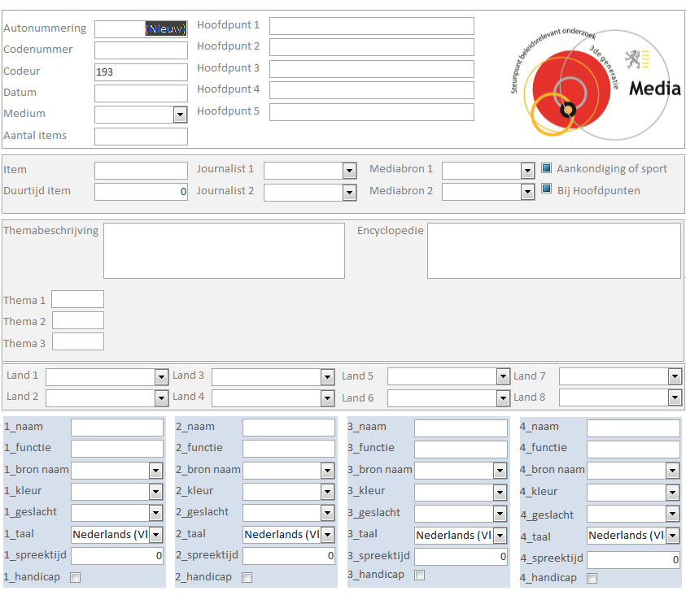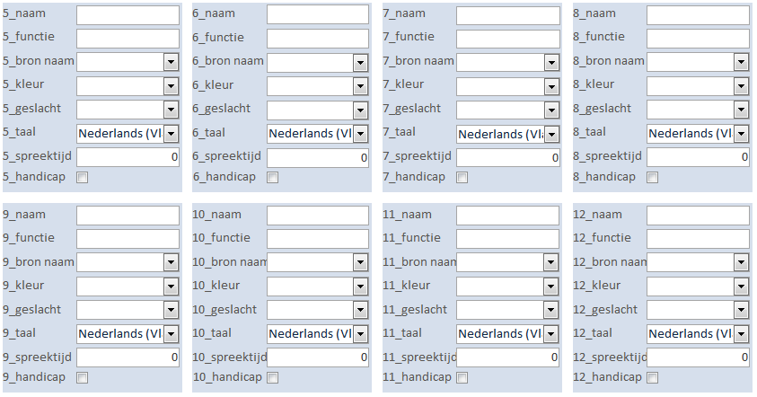

Hayes, A. F., & Krippendorff, K. (2007). Answering the call for a standard reliability measure for coding data. Communication Methods and Measures, 1, 77-89.
http://afhayes.com/spss-sas-and-mplus-macros-and-code.html
http://dfreelon.org/utils/recalfront/
Hayes’ macro for SPSS provides the possibility to estimate the accuracy of the krippendorff α obtained, by bootstrapping, Using confidence intervals, the user gets an idea of how likely it is that the variable tested would drop below (or rise above) certain thresholds for a comparable dataset, as such extending the significance of the reliability measure beyond the actually tested data.
Clausen, L. (2004) Localizing the Global: “Domestication” Processes in International News Production. Media, Culture & Society, 26, 1, 25-44.
coder 1 codes source 1 in actor field 3 whereas coder 2 codes source 1 in field 1 and coder 3 codes source 1 in field two and they all write the actor’s name differently. This means cleaning and manually composing coder reliability calculation files.
Riffe, D., Lacy, S, Fico, F. (2005) Analyzing Media Messages: Using Quantitative Content Analysis in Research, Routledge: New York, p. 224

