THE BECKETT DIGITAL MANUSCRIPT PROJECT

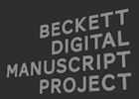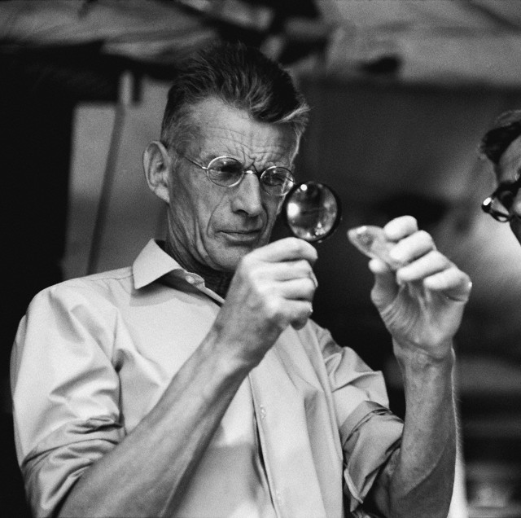

W O R K S H O P

Centre for Manuscript Genetics, University of Antwerp
Building D, D.228, Prinsstraat 13, 2000 Antwerp, Belgium
8 September 2014

10:00 Welcome and coffee

10:15 Dirk Van Hulle and Vincent Neyt
The BDMP and the ERC project ‘Creative Undoing and Textual Scholarship’

10:45 Ronald Dekker
Version Comparison with CollateX

11:15 Discussion: Collatex in the BDMP

Lunch break

13:30 Manuscript Transcription and Encoding Challenges: Presentations and Discussion

Mark Byron: Watt
Pim Verhulst: Beckett’s Radio Plays
Anthony Cordingley: Comment C’est / How It Is

15:30 Coffee Break

16:00 Manuscript Transcription and Encoding Challenges: Presentations and Discussion

Peter Fifield: Beckett’s Late Plays
Mark Nixon, Stephen Stacey: Beckett’s Shorter Prose
Georgina Nugent-Folan: Company / Compagnie

17:00 Conclusion

A Workshop on Digital Scholarly Editing, sponsored by the European Research Council (ERC),
the Digital Scholarly Editions Initial Training Network DiXiT (Marie Curie ITN), and the University of Antwerp
