THE BECKETT DIGITAL MANUSCRIPT PROJECT

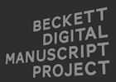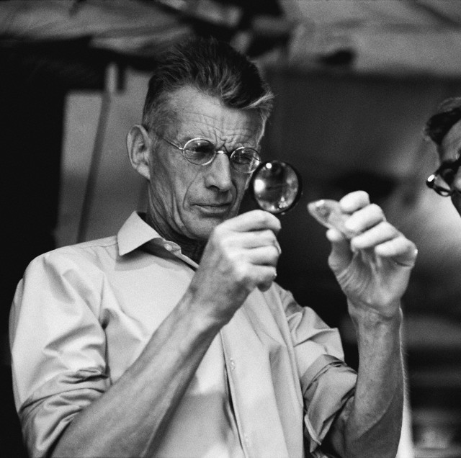

DiXiT Marie Curie ITN
T R A I N I N G W O R K S H O P

13-14 February 2017, Building D, D.014, Prinsstraat 13, 2000 Antwerp, Belgium

Monday 13 February:
09:30 – 10:00 Coffee

10:00 – 12:30 Introductory session for editors and students:
BDMP State of the Art: presentation of new and upcoming modules
10:00 Introduction - Dirk Van Hulle
10:10 Molloy and Malone Dies - Dirk Van Hulle, Vincent Neyt and Pim Verhulst
10:30 Watt - Mark Byron
10:40 Short Prose – Mark Nixon
10:50 How It Is - Anthony Cordingley
11:00 Company - Georgina Nugent-Folan
11:10 Waiting for Godot - Mark Nixon and Dirk Van Hulle
11:20 Endgame - Shane Weller and Dirk Van Hulle
11:30 Radio Plays - Pim Verhulst
11:40 Play – Olga Beloborodova
11:50 Film – Paul Ardoin
12:00 Late Plays - Peter Fifield

12:45 – 14:00 Lunch (Agora Café, on campus)

14:00 – 14:30 Project management and workflow (Vincent Neyt and Dirk Van Hulle)
14:30 – 15:00 Round-table discussion: Citation of BDMP modules, delivery schedules, etc.

15:00 – 15:30 Coffee break

15:30 – 17:30 Workshop image/text view (Vincent Neyt)

Tuesday 14 February:
09:30 – 10:00 Coffee

10:00 – 11:30 Problems and solutions (Vincent Neyt)
Example-based discussion of specific problems relating to encoding texts (crosswords, gaps, doodles, diagrams in stage directions, etc.)

11:30 – 12:00 Coffee break

12:00 – 12:20 Outreach and dissemination (Elli Bleeker and Aodhán Kelly)
12:20 – 13:00 Round-table discussion: outreach and dissemination, etc.
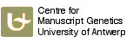
13:00 – 14:00 Lunch (Agora Café)

Organisation: Centre for Manuscript Genetics, University of Antwerp

A Workshop on Digital Scholarly Editing, sponsored by the European Research Council (ERC),
the Digital Scholarly Editions Initial Training Network DiXiT (Marie Curie ITN), and the University of Antwerp
