Supplementary Figures
The Cardiac Endothelial Cell Transcriptome in Neonatal, Adult, and Remodeling Hearts

Zarha Vermeulen, Ph.D.¹; Ligia Mateiu, M.D. Ph.D.²; Lindsey Dugaucquier, Pharm.D.¹; Gilles W. De Keulenaer, M.D. Ph.D.^{1,3}; Vincent F.M. Segers, M.D. Ph.D.^{1,4}

¹Laboratory of Physiopharmacology, University of Antwerp, Universiteitsplein 1, 2610 Antwerp, Belgium
²VIB Department of Molecular Genetics, University of Antwerp, Universiteitsplein 1, 2610 Wilrijk, Antwerp, Belgium
³Department of Cardiology, Middelheim Hospital, Lindendreef 1, 2020 Antwerp, Belgium
⁴Department of Cardiology, University Hospital Antwerp, Wilrijkstraat 10, 2650 Edegem, Belgium

Correspondence to Vincent F Segers, Laboratory of Physiopharmacology, University of Antwerp, Universiteitsplein 1, Building T, 2610 Wilrijk, Belgium. Phone: +3232659138. Email address: vincent.segers@uantwerpen.be

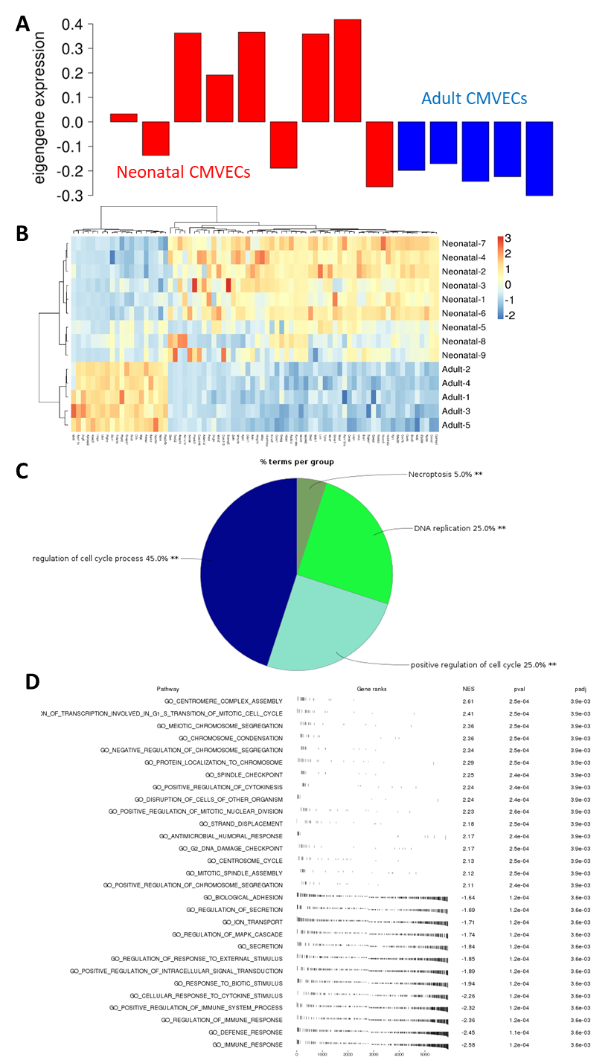
Supplementary Figure 1

Supplementary Figure 1. Pathway analysis of the brown module generated by co-expression network analysis. A) Eigengene expression in 9 neonatal CMVEC samples and 5 adult CMVEC samples. The eigengene is the first principal component of the module and serves as a summary of the expression profiles of all genes in the brown module. B) Heatmap of all significantly up- or down-regulated genes in the brown module. C) ClueGO pathway analysis showing all pathways related to the differential gene expression between neonatal and adult CMVECs in the brown module. D) fGSEA pathway analysis showing most relevant gene ontology pathways related to the differential gene expression between neonatal and adult CMVECs in the brown module. The upper part of the table relates to pathways up-regulated in neonatal CMVECs, whereas the lower part of the table relates to pathways up-regulated in adult CMVECs.

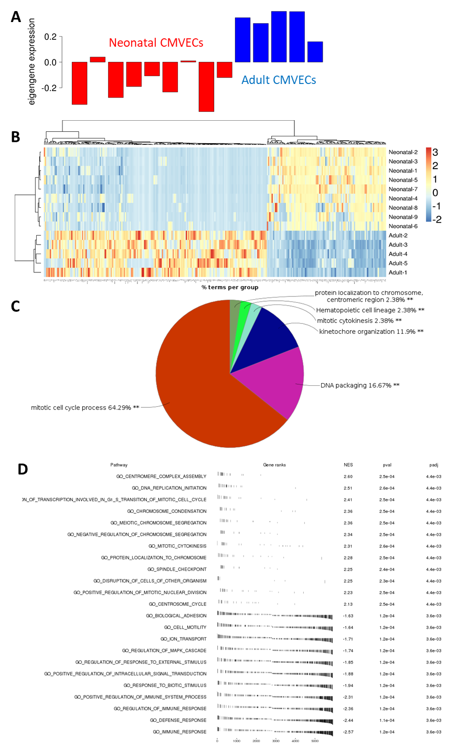
Supplementary Figure 2

Supplementary Figure 2. Pathway analysis of the turquoise module generated by co-expression network analysis. A) Eigengene expression in 9 neonatal CMVEC samples and 5 adult CMVEC samples. The eigengene is the first principal component of the module and serves as a summary of the expression profiles of all genes in the turquoise module. B) Heatmap of all significantly up- or down-regulated genes in the turquoise module. C) ClueGO pathway analysis showing all pathways related to the differential gene expression between neonatal and adult CMVECs in the turquoise module. D) fGSEA pathway analysis showing most relevant gene ontology pathways related to the differential gene expression between neonatal and adult CMVECs in the turquoise module. The upper part of the table relates to pathways up-regulated in neonatal CMVECs, whereas the lower part of the table relates to pathways up-regulated in adult CMVECs.

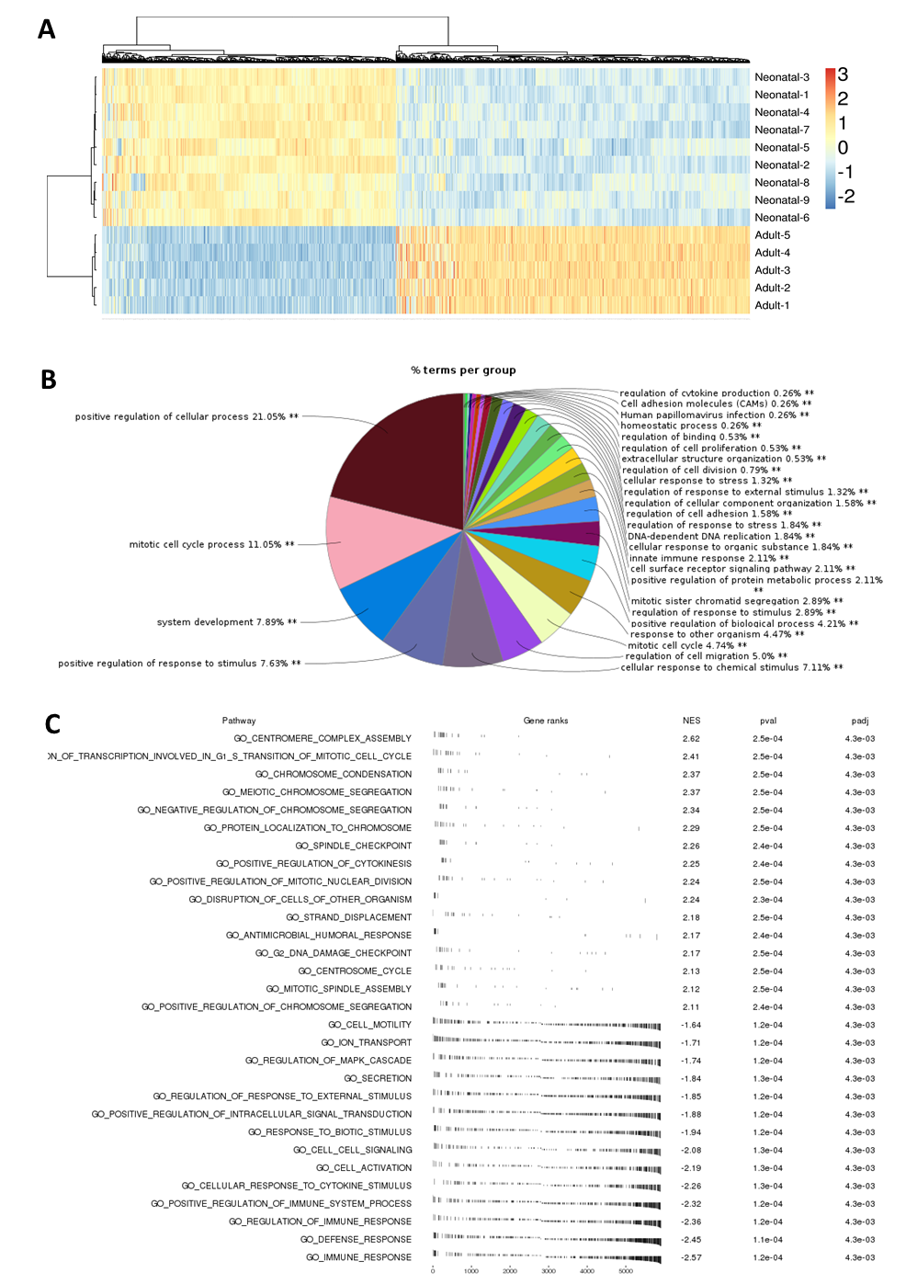
Supplementary Figure 3

Supplementary Figure 3. Pathway analysis of the grey module generated by co-expression network analysis. A) Heatmap of all significantly up- or down-regulated genes in the grey module. B) ClueGO pathway analysis showing all pathways related to the differential gene expression between neonatal and adult CMVECs in the grey module. C) fGSEA pathway analysis showing most relevant gene ontology pathways related to the differential gene expression between neonatal and adult CMVECs in the grey module. The upper part of the table relates to pathways up-regulated in neonatal CMVECs, whereas the lower part of the table relates to pathways up-regulated in adult CMVECs.

