A smaller alternative to large box lines?
- 01 Mar 2017
- Analysis
Shippers should invite smaller regional lines to enter the deepsea trades
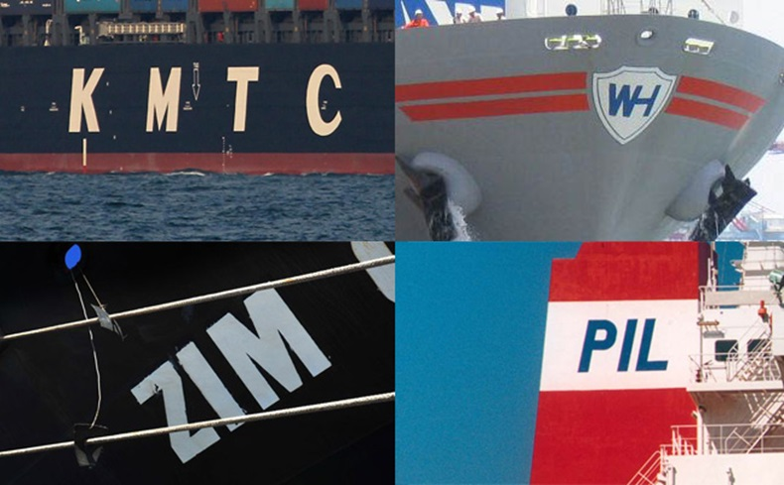
WHY are shippers so focused on the top-10 container lines at a time when they are dissatisfied with reduced supply chain efficiency? Why do shippers fear the contraction of the shipping market, when a battery of new liner operators could enter the global marketplace?
The answer to the first question is obvious. Many large and small shippers will not work with lower-ranked carriers because of the risk they perceive. Many lost money when Hanjin Shipping went bankrupt. This is still fresh in the memory, hence there is no appetite to work with smaller carriers.
But then, what is different from the situation at the beginning of the strategic alliances in 1994? At that time, 13 alliances on one trade were reduced to seven global alliances. The motivation of the top 20 liner companies joining forces to share resources on a worldwide scale was to cut costs, provide a more flexible service and respond to important changes on the demand side.
Today, the focus of carriers is not only surviving, but dealing with new challenges: reducing costs through bigger ships; managing excess tonnage; coping with weak demand; improving ship and container schedule reliability; improving networks; and entering the digital era.
From the shippers’ perspective, the difference from the past can be seen in the erosion of the number of services offered.
What can be learned from history? Table 1 compares the container capacity (in teu terms and market share) of the top 20 carriers and their rankings in 1995 with the estimated top 20 in April 2018 comprising the establishment of a joint venture including Japan's big three shipping groups — K Line, MOL and NYK.

Smaller alternative tab 010317.png
Click here for a larger PDF version of this table
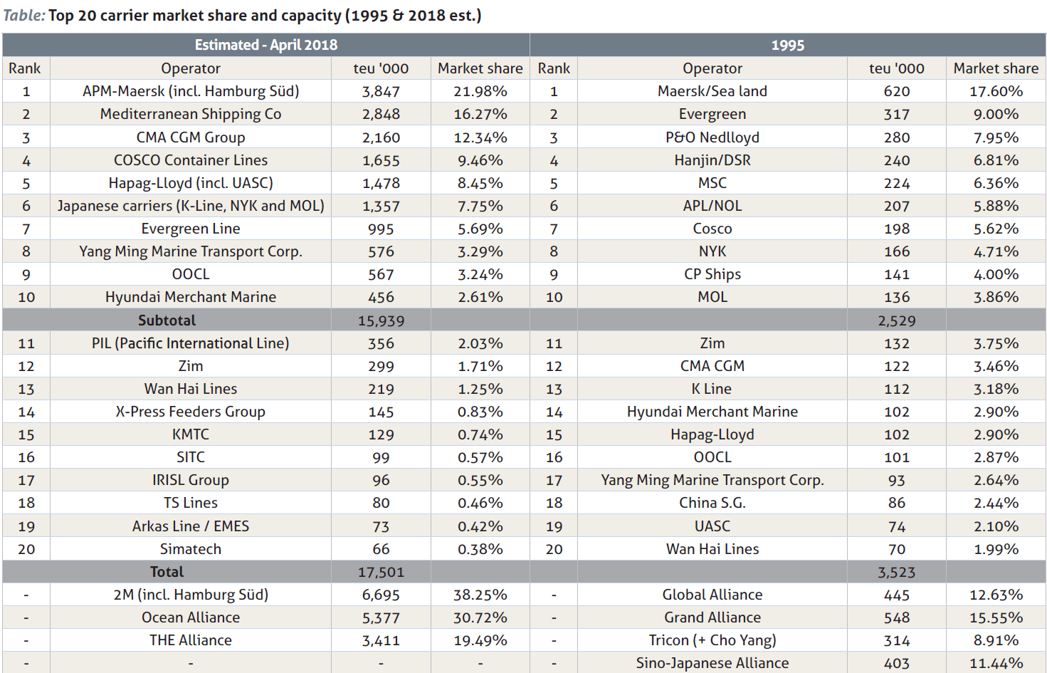
A first observation concerns the rise of regional liner operators formerly ranked in the 15-30 segment due to the recent consolidation wave. Yet, none of them had a global profile. But this did not hamper shippers in 1995 from co-operating with, for instance, CMA CGM and Hapag Lloyd, which climbed in rank as the result of acquisitions and a combined strategy of acquisition and co-operative agreements respectively. Other carriers (Hyundai Merchant Marine, OOCL, K Line and Yang Ming) grew via co-operative agreements.
Shippers attach great importance to parameters like capacity, sailing frequency, transit times and associated service quality, and recent financial performance. PIL, Zim, Wan Hai, X-Press Feeders and KMTC have a carrying capacity of over 100,000 teu, deploy a medium-sized portfolio of ships, operate outside alliances, offer predictable transit times and score high on reliability.
In terms of financial performance, Taiwan’s Wan Hai has posted consecutive quarters of positive operating margins. In 2014, Zim decided to focus on niche routes and improved its liner performance. IRISL has returned to the top 20 but is currently struggling with money transfers and disappointing demand.
Valuable alternatives?
Offering critical mass and ensuring long-run co-operation might convince medium-sized carriers to provide a wider scope of services.
But regional players cannot escape the pressure of declining freight rates either. Hence, the question becomes whether these carriers will invest in more ships; set up agencies, possibly through joint ventures; buy terminals; or digitalise their businesses (reliability is key in contracts with online retail giants).
To address the dynamics of the market, lower-ranked carriers are adapting their strategies. Three scenarios are possible.
First, the carriers ranked in the 11-20 segment might consider entering one of the three major alliances, setting up co-operative agreements between themselves or launching with a new alliance. PIL and Wan Hai are likely candidates for this.
Second, smaller carriers could be targeted for mergers or acquisitions. Mediterranean Shipping Co, for example, is in talks to buy a stake in Linea Messina, ranked number 43. In all likelihood, more consolidation is expected, particularly among the lower-ranked carriers.
Finally, smaller carriers can opt to remain independent and differentiate themselves on non-price parameters like services, reliability and speed of inland transfers. There might be a willingness to pay for quality on the part of the shipper. If price is not in question, shippers may look outside the larger carriers.
Professor Dr Christa Sys is holder of the BNP Paribas Fortis Chair Transport, Logistics and Ports and teaches at C-MAT, University of Antwerp
This article appears in the March edition of Containerisation International
Bron: https://lloydslist.maritimeintelligence.informa.com/LL025702/A-smaller-alternative-to-large-box-lines

