Write your title here

Author 1 Name¹, Author Name², Author Name³

¹Author Affiliation
E-mail
²Author Affiliation
E-mail
³Author Affiliation
E-mail

(NOTE: Please do not put page numbers, they will be added.)

Abstract
This sample paper describes the formatting requirements for CUMULUS ANTWERP 2023 conference proceedings. Every submission should begin with an abstract of maximum of 500 words, followed by a set of keywords. The abstract should be a concise statement of the problem, approach, and conclusions of the work described. It should clearly state the paper’s contribution to the CONNECTIVITY AND CREATIVITY IN TIMES OF CONFLICT conference themes.

Author keywords
Authors’ choice; of terms; separated; by semicolons; commas, within terms only; this section is required.

Introduction
This format is to be used for submissions that are published in the conference proceedings. We wish to give this volume a consistent, high-quality appearance. We therefore ask that authors follow some simple guidelines. You should format your paper exactly like this document. The easiest way to do this is to replace the content with your own material. All papers should be restricted in length to a maximum of six (6) pages (references excluded).

Page size and columns
All CUMULUS ANTWERP 2023 submissions should be on A4 page format (do not use US letter). On each page your material should be centered on a A4 page (217x210 mm), in one column: beginning 50 mm from the top of the page, with 55 mm margin on bottom of the page and with 45 mm margins on right and left side of the page. Right margins should be justified.

Text formatting
Please use an 8.5-point Source Sans Pro Regular font. Source Sans Pro is an open-source Google font that can be downloaded for your use at https://fonts.google.com/. Please use serif or non-proportional fonts only for special purposes, such as distinguishing source code text.

Text styles
The template uses MS Word text styles to facilitate text formatting, and we recommend you use these Styles instead of manually applying formatting. The applicable text styles are:
- Normal—for body text. Don’t use “Default Paragraph Font”.
- Heading 1, Heading 2, Heading 3
- Bullet list
- Numbered list
- Caption
- References—for bibliographic entries

Sections
The heading of a section should be in Source Sans Pro Bold 9.5-point, (Style: Heading 1). Sections should not be numbered.

Subsections
Headings of subsections should be in Source Sans Pro italic 9.5-point, (Style: Heading 2).

Sub-subsections
Headings of sub-subsections should be in Source Sans Pro, italic 8.5-point, (Style: Heading 3).

Language, style, and content
The written and spoken language of CUMULUS ANTWERP 2023 is English. Spelling and punctuation may use any dialect of English (e.g., British, Canadian, US, etc.) provided this is done consistently. Hyphenation is optional. To ensure suitability for an international audience, please pay attention to the following:
- Write in a clear and direct style of English
- Use common and basic vocabulary (e.g., use the word “unusual” rather than the word “arcane”).
- Briefly define or explain all technical terms. The terminology common to your practice/discipline may be different in other design practices/disciplines.
- Write acronyms in full the first time they are used in your text, followed by brackets, e.g., “UNITED NATIONS (UN)” and with Initials thereafter.
- Explain local references (e.g., not everyone knows all city names in a particular country).
- Explain “insider” comments. Ensure that your whole audience understands any reference whose meaning you do not describe (e.g., do not assume that everyone has used an Android phone or a particular application).
- Avoid colloquial language and puns, unless essential, in which case, explain them. Understanding phrases like “red herring” requires a cultural knowledge of English. Humor and irony are difficult to translate.
- Use unambiguous forms for culturally localized concepts, such as times, dates, currencies, and numbers (e.g., “1-5- 97” or “5/1/97” may mean 5 January or 1 May, and “seven o’clock” may mean 7:00 am or 19:00). For currencies, indicate equivalences in US dollars, e.g., “Waste streams to the value of £100 (approx. US$125)”
- Use inclusive language. Avoid where possible gender-specific pronouns (he, she) and words (chairman, mankind, craftsman). Use language that is gender-neutral (e.g., she or he, s/he, they; chair, humankind; crafter or crafts-practitioner). Be considerate in the use of diversity terms.
- If possible, use the full (extended) alphabetic character set for names of people, institutions, and places (e.g., Québec, Tromsø, Schwäbisch Gmünd, Århus, etc.). These characters are already included in most versions and variants of Helvetica, and Arial fonts.
- Do not rely on translation software for coherence.

Figures and Tables
The examples on this and following pages should help you get a feel for how figures and tables should be placed in the template, see Figure 1 and Table 1. Be sure to make images large enough so the important details are legible and clear. If you have text in the figure, make sure it is not smaller than 2pts from the regular font size. Your document may use color figures, which are included in the page limit; the figures must be usable when printed in black and white. You must cite the figures and tables in your text.

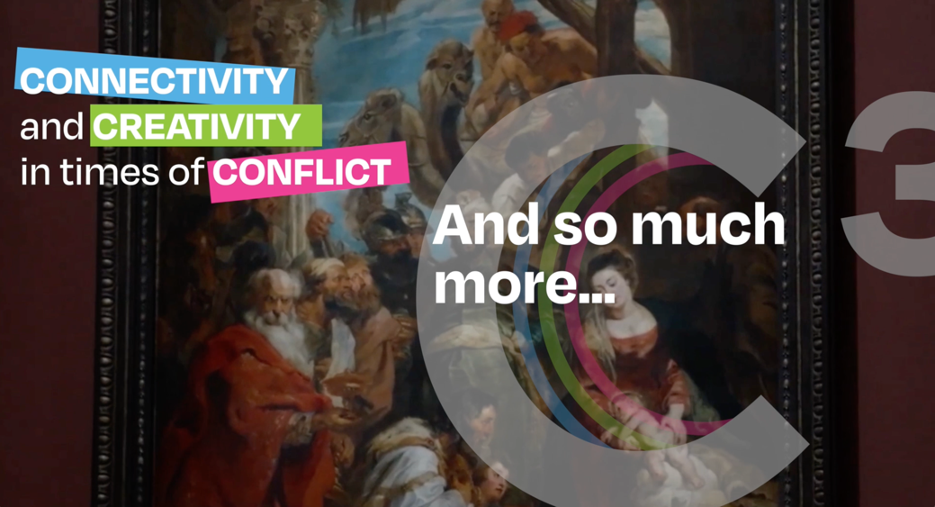
Figure 1. Insert a caption below each figure, and number all figures.
Short captions are centered, while long ones are justified. We suggest selecting the image and then using Insert, Caption. Captions should be Source Sans Pro regular font 7,5-point (Style: Caption), and all captions, figures and tables should be centered; for tables the caption should appear above the title, using the Tablecaption style.
Use high-resolution images, 300+ dpi, legible if printed in color or black-and-white. If you aren’t familiar with Word’s handling of pictures, we offer one tip: the “format picture” dialog is the key to controlling position of pictures and the flow of text around them. You access these controls by selecting your picture, then choosing “Picture…” from the “Format” menu. As for the “picture” tab in that dialog, we recommend using Photoshop, Preview, or other graphics software to scale images, rather than scaling them after you have placed them in Word.
Table 1. Table caption should be placed above the table.
Heading level | Example | Font size and style
Title (centered) | Article Title | Source Sans Pro 12 point, bold
1st-level heading | Heading | Bold 9.5-point
2nd-level heading | Sub-heading | Italics 9.5-point
3rd-level heading | Run-in Heading in Bold. Text follows | Italics 8.5-point

Page numbering, headers, and footers
Your final submission should not contain footer or header information at the top or bottom of each page. Specifically, your final submission should not include page numbers. Page numbers will be added to the PDF when the proceedings are assembled.

Producing and testing pdf files
Submit your final paper as a word document. We recommend that you produce a test PDF version of your submission well before the final deadline.

Conclusion
It is important that you write for the CUMULUS audience. State clearly what you have done, not merely what you plan to do, and explain how your work is different from previously published work. Please consider what the reader will learn from your submission, and how they will find your work useful. If you write with these questions in mind, your work is more likely to be successful, both in being accepted into the conference, and in influencing the work of our field.

Acknowledgments
Sample text: We thank all the volunteers, and all publications support and staff, who wrote and provided helpful comments on previous versions of this document. Authors 1, 2, and 3 gratefully acknowledge the grant from NSF (#1234-2012-ABC). This is just an example.

References and citations
Use APA style for your references and citing them in your text. Your references, such as (Ratto, 2011) should be published materials accessible to the public. Internal technical reports may be cited only if they are easily accessible (i.e., you provide the address for obtaining the report within your citation) and may be obtained by any reader for no more than a nominal fee. Proprietary information may not be cited.

References
Allwood, J.M., Cullen J.M., Carruth M.A., Cooper D.R., McBrien M., Milford R.L., Moynihan M., Patel A.C.H. (2014) Sustainable Materials with Both Eyes Open. UIT Cambridge, England
Attia, M. & Edge, J. (2017) Be(com)ing a reflexive researcher: a developmental approach to research methodology, Open Review of Educational Research, 4:1,33-45, DOI: 10.1080/23265507.2017.1300068
Newson, A, Suggett, E., & Sudjic, D. (2017), Designer maker user, London: Phiadon
Norris, J (2016) A-Z of craft: A is for artisan, Crafts, September/October 2016, p.45
Ratto, M. (2011). Critical making: Conceptual and material studies in technology and Social Life. The Information Society, 27(4), 252–260. https://doi.org/10.1080/01972243.2011.583819
Redström, J. (2017) Making design theory, The MIT Press.
Reller, A. & Dießenbacher, J (2016) Are there enough resources for our lifestyle? how resource strategy leads from wasting materials to using them. In Stebbing, P., & Tischner, U. (Eds.). Changing Paradigms. Aalto: Aalto University School of Arts, Design and Architecture, pp.154-166
Stebbing, P., & Tischner, U. (Eds.) (2016) Changing paradigms. Aalto: Aalto University School of Arts, Design and Architecture

